**Summary Report**

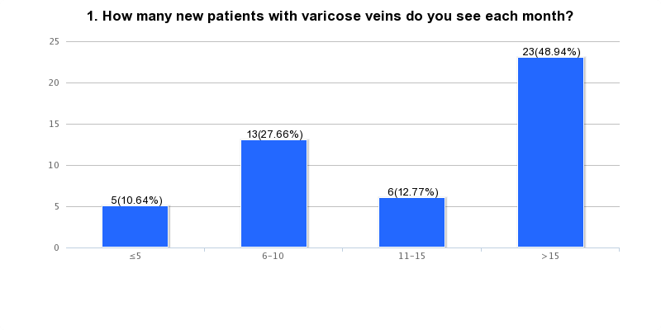

**2. How many GSV-ablation procedures do you perform each month?**

* 10
* 2-3
* 15-20
* 30-40
* 10
* 4
* >20
* 10-15
* 50-60
* 8-10
* 10-12
* 40
* 20-25
* 15
* 4-8
* 4-6
* 30
* 30
* 10
* 15
* 1-2
* 4
* 20-25
* 20
* 15
* 8
* 20-25
* 20
* 5
* 5
* none
* 100
* 20
* 25-30
* 20
* 20
* 10
* 10
* 5
* 30-40
* 90-110
* 90-110

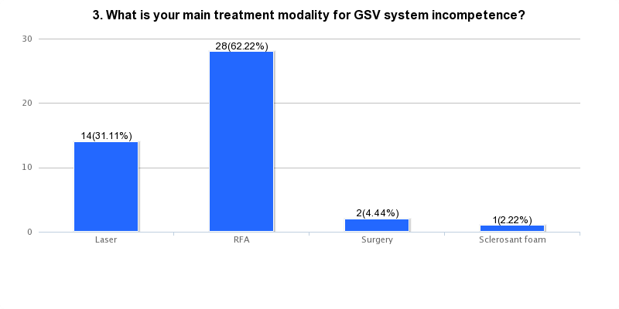

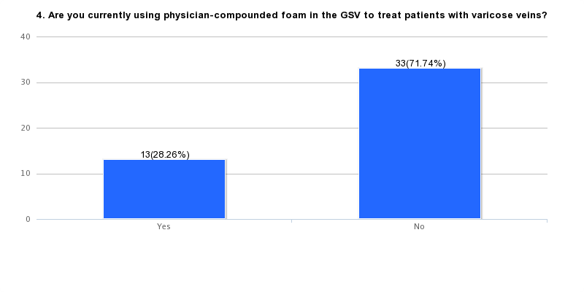

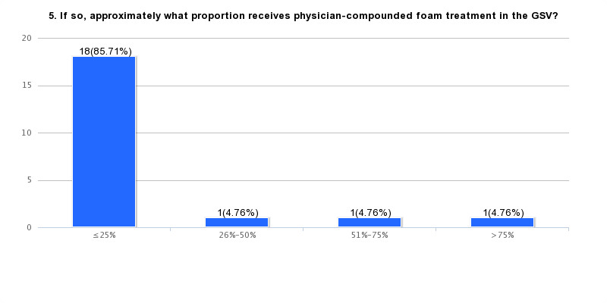

**Please circle the number that best describes your agreement with the following statement for each presentation. (1 = Strongly Disagree; 5 = Strongly Agree)**44 Responses

|  |  | | | | | |
| --- | --- | --- | --- | --- | --- | --- |
|  | 1 | 2 | 3 | 4 | 5 | Average Rating |
| **6. The following presentation was useful for my practice:** | | | | | | | | | |
| **Varithena® and the Treatment of GSV System Incompetence** | **1***(2.38%)* | **2***(4.76%)* | **13***(30.95%)* | **16***(38.10%)* | **10***(23.81%)* | 3.8 |  |  |  |
| **Accessing Varithena® For Your Patients: What You Need to Know** | **3***(7.89%)* | **1***(2.63%)* | **10***(26.32%)* | **15***(39.47%)* | **9***(23.68%)* | 3.7 |  |  |  |
|  | | | | | | |

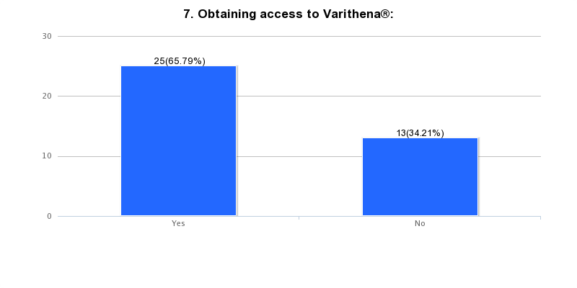

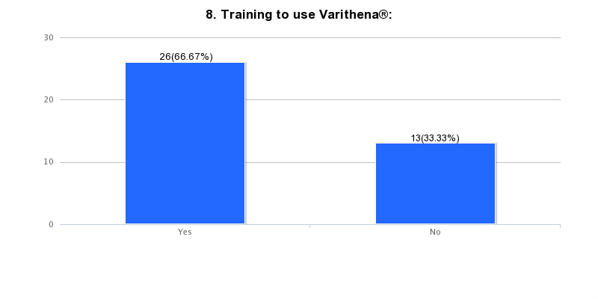

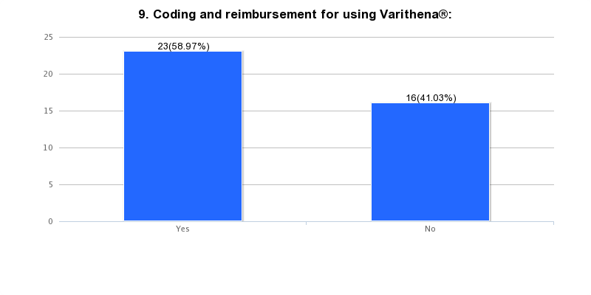

**10. What was the most valuable topic discussed during the symposium?**

* **Benefit**
* **Reimbursement and closure rates and DVT occurance**
* **Reimbursement and claims processing**
* **New information**
* **Billing for procudure**
* **MD compounded foam vs. Varithena**
* **non- thermal ablation treatment**
* **coding**
* **technique of procedure**
* **The procedure**
* **Payment**
* **Reimbursement**
* **all good**
* **New product**
* **Efficacy**
* **obtaining reimbursement for venous procedure**
* **Reimbursement**
* **Efficacy for Varithena**
* **Trial, billing**

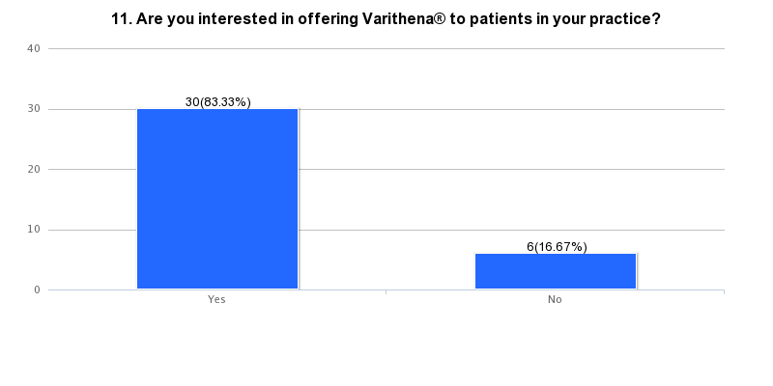

**12. Any topics that you would find of interest for future symposia? Please list:**

* **Different billing talk - NO UNDERSTANDING**
* **cost difference, hemosiderin deposits and inflammation**
* **cost difference, hemosiderin deposits and inflammation**

**13. Additional comments:**

* **The appeals and denial process was depressing. It is too much work.**
* **Believe the product will work - more concerned with reimbursement. Do not have staff or time for repeated calls and chasing claim submission**
* **Already uses in office. Should have single patient canister.**
* **Uses laser, RFA and surgery to treat modality for GSV system incompetence.**
* **Already uses in office**
* **I have already contacted rep, am waiting for CPT code**
* **If it is financially viable , I will do it.**
* **Uses both Laser and RFA; already has resources, so no more information needed**
* **Thanks**
* **Uses both laser and RFA**
* **uses both RFA and surgery**
* **Thanks. Availability in South Africa**
* **Already trained on this**